***COLLEGE INFORMATION BANK***

*A*

*Mini Project Report Submitted in partial fulfilment of the*

*Requirements for the award of the Degree of*

## BACHELOR OF ENGINEERING

IN

## INFORMATION TECHNOLOGY

By

## <V. HARSHITA><1602-20-737-134>

**<D. LAKSHMI BHAVANI><1602-20-737-141>**

## <K. NIDISH><1602-20-737-147>



**Department of Information Technology Vasavi College of Engineering (Autonomous)**

## VASAVI COLLEGE OF ENGINEERING (AUTONOMOUS)

### (AFFILIATED TO OSMANIA UNIVERSITY) HYDERABAD - 500 030

**Department of Information Technology**



### DECLARATION BY CANDIDATE

We, **<V. HARSHITA>, <D. LAKSHMI BHAVANI>, <K. NIDISH>,** bearing hall ticket number, **<1602-20-737-134>,<1602-20- 737-141>,<1602-20-737-147>**

hereby declare that the project report entitled **<”COLLEGE INFORMATION BANK”>** Department of Information Technology, Vasavi College of Engineering, Hyderabad, is submitted in partial fulfillment of the requirement for the award of the degree of **Bachelor of Engineering** in **Information Technology**

This is a record of bonafide work carried out by me and the results embodied in this project report has not been submitted to any other university or institute for the award of any other degree or diploma.

### <V. HARSHITA><1602-20-737-134>

**<D. LAKSHMI BHAVANI><1602-20-737-141>**

**<K. NIDISH><1602-20-737-147>**

## VASAVI COLLEGE OF ENGINEERING (AUTONOMOUS)

### (AFFILIATED TO OSMANIA UNIVERSITY) HYDERABAD - 500 030

**Department of Information Technology**



### BONAFIDE CERTIFICATE

This is to certify that the project entitled “**COLLEGE INFORMATION BANK**” being submitted by **V. HARSHITA ,D. LAKSHMI BHAVANI, K. NIDISH** bearing **1602-20-737-134, 1602-20-737-141**,**1602-20-737-147**, in partial fulfillment of the requirements for the completionof MINI PROJECT of Bachelor of Engineering in Information Technology is a record of bonafide work carried out by them under my guidance.

Internal Guide External Examiner Dr.K. Ram Mohan Rao Dr.S.Prashanth HOD, IT

## ACKNOWLEDGEMENT

We thank the department of INFORMATION TECHNOLOGY, for introducing the subject “Mini Project-2” in BE fifth semester.

We would also like to show our appreciation to our Honorable principal, Dr S V Ramana sir, our HOD K. Ram Mohan Rao for supporting us and our mini project lecturer, Dr.S.Prashanth sir , for letting us properly understand the process of doing a project and for providing valuable insight and expertise that has greatly assisted us in the making of the project.

**TABLE OF CONTENTS:**

1. ABSTRACT and INTRODUCTION
   1. PURPOSE
   2. INTENDED AUDIENCE
   3. PRODUCT SCOPE
   4. PROBLEM DEFINITON
2. RELATED WORK
3. PROPOSED WORK
   1. USE CASES
   2. UI PROTOTYPES OR SCREENSHOTS
   3. ARCHITECTURE
   4. DESIGN
   5. IMPLEMENTATION
      1. MODULES
      2. ALGORITHMS USED
      3. CODE AND GITHUB LINKS
   6. TESTING
4. RESULTS
5. DISCUSSION AND FUTURE WORK
6. REFERENCES

**CHAPTER 1.**

**ABSTRACT**

* The universities in India provide various courses on different disciplines and the students have to compare these courses on the basis of various parameters
* The courses range from Bachelor, Masters and P.hd courses.
* To make it a go to platform which helps students gather information

About various colleges and the courses offered by them.

* A website that helps students search across various courses and colleges and decide the best one of them.
* To save time and efforts of the students spent in decision making.
* To help students not fall prey of lack of information/misinformation.
* The integration of these details on a single platform will enhance the transparency and remove difficulty being faced by the students.

# INTRODUCTION

* Students after completing their intermediate, or secondary, higher education they want to join in best universities and colleges.
* Each college or university has its own web site which contains all information about the college.
* But, how do students know which is best college according to their criteria, how do they compare colleges according to various categories.
* It is good if we can find all the details of the colleges at one place , so that there is no confusion for student to choose a college according to their requirements.
* Comparing colleges, sorting colleges according to ranking and placement packages is the most common criteria , where students look for.
  1. **PURPOSE**

An integrated web site which contains all the details and information about various colleges so that the students does not waste their time while selecting colleges and also they did not fall under misinformation, as this website provides accurate data to students.

## INTENDED AUDIENCE

The intended audience for this project is everyone who wants to know about information regarding various colleges.

* + 1. Students and parents
    2. Website visitors either for inquiry or gathering information.

## PRODUCT SCOPE

* To make the website Available for wide Range of

Colleges.

* To Enable the users interact with the Alumni of the

Respective Colleges.

## PROBLEM DEFINATION

### Background: There are more than 1000 universities in India and these universities are offering thousands of undergraduate, post-Graduate and doctorate courses. The students applying for these universities have to do a lot of comparison for choosing the university/course on the basis of various criteria’s. A PAN India university information bank is required for accessing course details, comparison of courses, facilities and faculty, admission, tracking student mobility, viewing results, evaluation and certification, verification of certificates, joint online courses (MOOCs). This will help both student and faculty communities for self improvement through comparison and emulations. Lack of information is leading to self glorification and inbreeding among University and College student and faculty members.

# CHAPTER 2

# RELATED WORK –

* There already exist websites where it provides information about various colleges and universities.
* But, those website does not provide accurate information or latest information about colleges.
* This website is user friendly, provides accurate data about colleges and universities, so that students will not fall to prey for misinformation .

# CHAPTER 3 PROPOSED WORK –

* 1. **Use cases –**

**USE CASE 1:-**

* Use Case Name:-College Information
* Actors:-User , System
* Description:- To get the information about college which user want to know
* Pre Condition:- College Selection
* Post Condition:-Getting information about college by clicking

**USE CASE 2:-**

* To Sort the colleges according to the NIRF ranking or by the average salary .
* Use Case Name:-College Information
* Actors:-User , System
* Description:- To sort the selected colleges
* Pre Condition:- College Selection
* Post Condition:-Getting information about college by clicking

# UI prototypes or screenshots

# 

# Architecture and Technology used

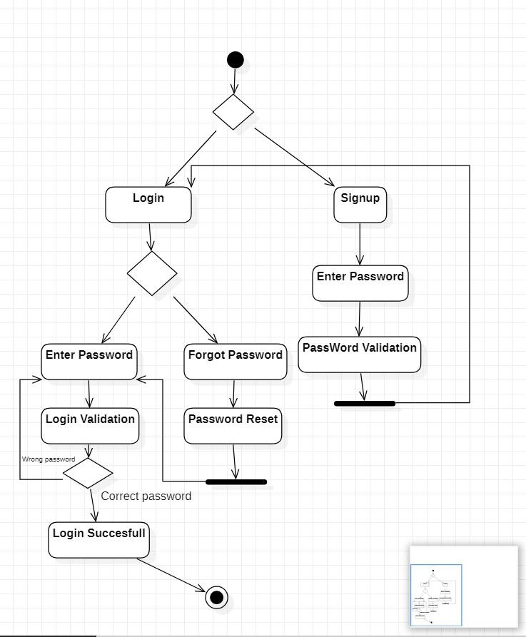

### Technology used –

* TEXT EDITOR: VISUALSTUDIO CODE
* **Front end:**

**HTML**(to create the structure of the website)

**CSS(**Cascading Style Sheets to style and web Layout**)**

**JAVASCRIPT(**to make page Responsive)

* **Back end:**

**EXPRESS JS(**to make a single page or multipage web app**)**

**NODE JS(**to handle huge I/O operations**)**

# Design –

**DATA FLOW DIAGRAM**

* 1. **Implementation :**
     1. **Modules :**
  2. **Signup :**Allows user to signup
     1. :Notifies user on a invalid signup

A error will be pop out if the password format or username format is wrong.

* + 1. Allows user to register.

User is allowed to choose the preferences of their choice.

* 1. **Login :** Allows user to login

Every login ,The grid reshuffles the images.

* + 1. **:**Notifies user on a invalid login

A email will be sent if the login is invalid

* 1. **:**Allows user to reset password

Allows user to use forgot password option.

* + 1. **Algorithms used :**

Algorithms used are sorting techniques for sorting colleges according to to their placement packages and rankings , it is done by using quick sort and also by using html tables .

**3.5.2 Code :**

**Index.html :**

<!DOCTYPE html>

<html lang="en">

<head>

<meta charset="UTF-8">

<meta http-equiv="X-UA-Compatible" content="IE=edge">

<meta name="viewport" content="width=device-width, initial-scale=1.0">

<title>DATABASE PULSE</title>

<link rel="stylesheet" href="https://pro.fontawesome.com/releases/v5.10.0/css/all.css"/>

<link rel="stylesheet" href="style.css"

</head>

<body>

<!--navigation-->

<nav>

<img src="/Users/ishu/Downloads/dbpulse/images/l.jpg" alt="">

<div class="navigation">

<ul>

<li><a class="active" href='#'>Home</a></li>

<li><a href="about.html">About</a></li>

<li><a href="colleges.html">Colleges</a></li>

<li><a href="contact.html">Contact</a></li>

</ul>

</div>

</nav>

<!--HOME-->

<section id="home">

<h2>Boost Up Your Career with DATABASE PULSE</h2>

<p>This website helps the students to get into the best Educational Institutes to Change their better today into Best Tommorow </p>

<div class="btn">

<a class ="blue" href="#">Learn More</a>

<a class ="yellow" href="#">Visit Colleges</a>

</div>

</section>

<!--features-->

<section id="features">

<h1>UNIQUE features</h1>

<div class="fea-base">

<div class="fea-box">

<i class="fa-solid fa-sort"></i>

<h3>Sort</h3>

<p>Sorting based on Avg salaries in the past 3 years

and the NIRF Ranking</p>

</div>

</div>

</section>

<!--colleges-->

<section id="college">

<h1>Colleges</h1>

<p>Engineering Colleges in Hyderabad</p>

<div class= "college-box">

<div class="colleges">

<img src="/Users/ishu/Downloads/dbpulse/images/vce.jpeg" alt="">

<div class="details">

<span>updated 28/11/22</span>

<a href="/Users/ishu/Downloads/dbpulse/images/BRANCHES.docx" >

<h6>VASAVI COLLEGE OF ENGINEERING </h6></a></li>

<div class="star">

<i class="fas fa-star"></i>

<i class="fas fa-star"></i>

<i class="fas fa-star"></i>

<i class="fas fa-star"></i>

</div>

<div class="NAACGRADE">

NAAC:A++

</div>

</div>

</div>

<div class="colleges">

<img src="/Users/ishu/Downloads/dbpulse/images/cbit.jpeg" alt="">

<div class="details">

<span>updated 28/11/22</span>

<a href="/Users/ishu/Downloads/dbpulse/images/BRANCHES.docx" >

<h6>CHAITANYA BHARATHI INSTITUTE OF TECHNOLOGY </h6></a></li>

<div class="star">

<i class="fas fa-star"></i>

<i class="fas fa-star"></i>

<i class="fas fa-star"></i>

<i class="fas fa-star"></i>

</div>

<div class="NAACGRADE">

NAAC:A++

</div>

</div>

</div>

<div class="colleges">

<img src="/Users/ishu/Downloads/dbpulse/images/VNRVJIETLogo.png" alt="">

<div class="details">

<span>updated 28/11/22</span>

<a href="/Users/ishu/Downloads/dbpulse/images/Vnr.jpeg" >

<h6>VNR VIGNANA JYOTHI COLLEGE OF ENGINEERING </h6></a></li>

<div class="star">

<i class="fas fa-star"></i>

<i class="fas fa-star"></i>

<i class="fas fa-star"></i>

<i class="fas fa-star"></i>

</div>

<div class="NAACGRADE">

NAAC:A++

</div>

</div>

</div>

<div class="colleges">

<img src="/Users/ishu/Downloads/dbpulse/images/JNTU_Hyderabad_logo.png" alt="">

<div class="details">

<span>updated 28/11/22</span>

<a href="/Users/ishu/Downloads/dbpulse/images/jntu.jpeg" >

<h6>JAWAHARLAL NEHRU TECHNOLOGICAL UNIVERSITY HYDERABAD </h6></a></li>

<div class="star">

<i class="fas fa-star"></i>

<i class="fas fa-star"></i>

<i class="fas fa-star"></i>

<i class="fas fa-star"></i>

</div>

<div class="NAACGRADE">

NAAC:A++

</div>

</div>

</div>

<div class="colleges">

<img src="/Users/ishu/Downloads/dbpulse/images/nara.webp" alt="">

<div class="details">

<span>updated 28/11/22</span>

<a href="/Users/ishu/Downloads/dbpulse/images/narayanamma.jpeg" >

<h6>G NARAYANAMMA COLLEGE OF ENGINEERING </h6></a></li>

<div class="star">

<i class="fas fa-star"></i>

<i class="fas fa-star"></i>

<i class="fas fa-star"></i>

<i class="fas fa-star"></i>

</div>

<div class="NAACGRADE">

NAAC:A+

</div>

</div>

</div>

<div class="colleges">

<img src="/Users/ishu/Downloads/dbpulse/images/BVRIT-logo-big-1.png" alt="">

<div class="details">

<span>updated 28/11/22</span>

<a href="/Users/ishu/Downloads/dbpulse/images/bvrit.jpeg" >

<h6>BVRAJU INSTITUTE OF TECHNOLOGY</h6></a></li>

<div class="star">

<i class="fas fa-star"></i>

<i class="fas fa-star"></i>

<i class="fas fa-star"></i>

<i class="fas fa-star"></i>

</div>

<div class="NAACGRADE">

NAAC:A

</div>

</div>

</div>

<div class="colleges">

<img src="/Users/ishu/Downloads/dbpulse/images/MGIT_New_logo.png" alt="">

<div class="details">

<span>updated 28/11/22</span>

<a href="/Users/ishu/Downloads/dbpulse/images/jntu.jpeg" >

<h6>MAHATMA GANDHI INSTITUTE OF TECHNOLOGY </h6></a></li>

<div class="star">

<i class="fas fa-star"></i>

<i class="fas fa-star"></i>

<i class="fas fa-star"></i>

<i class="fas fa-star"></i>

</div>

<div class="NAACGRADE">

NAAC:A+

</div>

</div>

</div>

<div class="colleges">

<img src="/Users/ishu/Downloads/dbpulse/images/vardaman.jpeg" alt="">

<div class="details">

<span>updated 28/11/22</span>

<a href="/Users/ishu/Downloads/dbpulse/images/vardhaman.jpeg" >

<h6>VARDAMAN COLLEGE OF ENGINEERING</h6></a></li>

<div class="star">

<i class="fas fa-star"></i>

<i class="fas fa-star"></i>

<i class="fas fa-star"></i>

<i class="fas fa-star"></i>

</div>

<div class="NAACGRADE">

NAAC:A

</div>

</div>

</div>

<div class="colleges">

<img src="/Users/ishu/Downloads/dbpulse/images/cvr.jpg" alt="">

<div class="details">

<span>updated 28/11/22</span>

<a href="/Users/ishu/Downloads/dbpulse/images/vardhaman.jpeg" >

<h6>CVR COLLEGE OF ENGINEERING </h6></a></li>

<div class="star">

<i class="fas fa-star"></i>

<i class="fas fa-star"></i>

<i class="fas fa-star"></i>

<i class="fas fa-star"></i>

</div>

</div>

<div class="NAACGRADE">

NAAC:A

</div>

</div>

</div>

</section>

<!--registration-->

<section id="registration">

<div class="form"

<h3>create the account and start Exploring!!</h3>

<input type="text" placeholder="Name" name="" id="">

<input type="text" placeholder="Email" name="" id="">

<input type="text" placeholder="PhoneNumber" name="" id="">

<div class="btn">

<a class ="blue" href="#">Submit</a>

</div>

</section>

<footer>

<div class="footer-col">

<h3>Newsletter</h3>

<p>Trust our website for True Results!!</p>

<div class="subscribe">

<input type="text" placeholder="Your Email Address">

<a href="#" class ="yellow">SUBSCRIBE</a>

</div>

</div>

<div class="copyright">

<p>This template is made by 1602-20-737-141,134,147</p>

<div class="pro-links">

<i class="fab fa-facebook-f"></i>

<i class="fab fa-instagram"></i>

<i class="fab fa-linkedin-in"></i>

</div>

</div>

</footer>

</body>

</html>

**Style.css:**

@import url('https://fonts.googleapis.com/css2?family=Poppins:wght@100;200;300;400;500;600;700;800;900&display=swap');

*{

margin: 0;

padding: 0;

box-sizing: border-box;

}

body{

font-family: 'Poppins',sans-serif;

}

h1 {

font-size:n2.5rem;

font-weight:700;

color:rgb(35,35,85);

}

span{

font-size: .9rem;

color: #757373;

}

h6{

font-size:1.1rem;

color: rgb(24,24,49);}

nav {

display: flex;

position: fixed;

width: 100%;

background-color:whitesmoke;

flex-direction:row;

justify-content: space-between;

align-items: center;

padding:1vw 8vw;

box-shadow:2px 2px 10px rgba(0,0,0,0.15);

z-index: 999;

}

nav img{

width :150px;

cursor:pointer;

}

nav .navigation ul{

display: flex;

justify-content: flex-end;

align-items : center;

}

nav .navigation ul li{

list-style:none;

margin-left:30px;

}

nav .navigation ul li a{

text-decoration:none;

color:rgb(21,21,100);

font-size:16px;

font-weight:500;

}

nav.navigation ul li a.active,

nav .navigation ul li a:hover{

color: red;

}

#home{

background-image: linear-gradient(rgba(96, 4, 153, 0.3),rgba(2, 56, 12, 0.7)),url("/Users/ishu/Downloads/dbpulse/images/back.jpeg");

width:100%;

height:100vh;

background-size: cover;

background-position: center;

display: flex;

flex-direction: column;

justify-content: center;

align-items: center;

padding-top: 40px;

}

#home h2{

color: rgb(17, 175, 218);

font-size:2.2rem;

letter-spacing: 1px;

}

#home p{

width: 50%;

color:#fff;

font-size:0.9rem;

line-height:25px;

}

#home .btn{

margin-top:30px;

}

#home a{

text-decoration:none;

font-size:0.9rem;

padding:13px 35px;

background-color: #fff;

font-weight: 600;

border-radius: 5px;

}

#home a.blue{

color: #fff;

background: rgb(21,21,100);

}

#home a.blue:hover{

background: #fff;

color: rgb(21,21,100);

}

#home a.yellow{

color: #fff;

background: #FDC938;

}

#home a.yellow:hover{

color: #FDC938;

background: #fff;

}

#features{

padding: 5vw 8vw 0 8vw;

text-align: center;

}

#features .fea-base{

display: grid;

grid-template-columns: repeat(auto-fit,minmax(320px,1fr));

grid-gap:1rem;

margin-top:50px;

}

#features .fea-box{

background: #fff;

text-align: start;

}

#features .fea-box i{

font-size:2.3rem;

color:rgb(44, 44, 80);

}

#features .fea-box h3{

font-size: 1.2rem;

font-weight: 600;

color: rgb(1, 4, 35);

padding:13px 0 7px 0;

}

#features .fea-box p{

font-size: 1rem;

font-weight: 400;

color: rgb(61, 14, 172);

}

#college{

padding: 8vw 8vw 8vw 8vw;

text-align: center;

}

#college .college-box{

display:grid;

grid-template-columns: repeat(auto-fit,minmax(320px,1fr));

grid-gap: 1rem;

margin-top:50px;

}

#college .colleges{

text-align: start;

background: #F9F9ff;

height: 100%;

position: relative;

}

#college .colleges img{

width: 30%;

height: 30%;

background-size: cover;

background-position: center;

}

#college .colleges .details{

padding:15px 15px 0 15px;

}

#college .colleges .details i{

color: #FDC938;

font-size: .9rem;

}

#college .colleges .NAACGRADE{

background-color: rgb(72, 2, 102);

color: #fff;

line-height: 90px;

width: 90px;

height: 90px;

text-align: center;

border-radius: 70%;

}

#registration{

padding: 6vw 8vw 6vw 8vw;

background-image: linear-gradient(rgba(99,112,168,0.5),rgba(81,91,233,0.5)),url("/Users/ishu/Downloads/dbpulse/images/abouth.jpeg");

width: 100%;

height: 100%;

background-size: cover;

background-position: center;

display: flex;

justify-content: space-between;

align-items: center;

}

#registration .form{

background:#fff;

border-radius: 8px;

display: flex;

flex-direction: column;

padding:40px;

box-shadow: 0 8px 32px 0 rgba(31,38,135,0.37);

}

#registration .form input{

margin :15px;

padding:15px 10px;

border: 1px solid rgb(84,40,241);

outline: none;

}

#registration .form a.yellow{

color:#F9F9ff;

background: #FDC938;

transition: 0.3s ease;

}

#registration .form a.yellow :hover{

color:rgb(21,21,100);

background: #fff;

}

footer{

padding:8vw;

background-color: #101C32;

display: flex;

justify-content: space-between;

align-items: flex-start;

flex-wrap: wrap;

}

footer .footer-col{

padding-bottom: 40px;

}

footer h3{

color: rgb(241,240,245);

font-weight:600;

padding-bottom: 20px;

}

footer li{

list-style: none;

color:#7b838a;

padding: 10px 0;

font-size: 15px;

cursor: pointer;

}

footer li :hover{

color:rgb(241,240,245)

}

footer p{

color:#7b838a;

}

footer .subscribe{

margin-top: 20px;

}

footer input{

width:220px;

padding:15px 12px;

background: #334F6C;

border: none;

outline: none;

color: #fff;

}

footer .subscribe a{

text-decoration:none;

font-size:0.9rem;

padding:12px 15px;

background-color: #fff;

font-weight: 600;

}

footer .subscribe a.yellow{

color: #fff;

background: #FDC938;

transition: 0.3s ease;

}

footer .subscribe a.yellow :hover {

color:rgb(21,21,100);

background: #fff;

}

footer .copyright{

margin-top: 20px;

display: flex;

justify-content: space-between;

align-items: center;

width:100%;

flex-wrap: wrap;

}

footer .copyright .pro-links {

margin-top:15px;

}

footer .copyright .pro-links i{

background-color:#5f7185;

color:#fff;

}

footer .copyright .pro-links i :hover{

background: #FDC93B;

color:#2c2c2c;

}

/About/

#about-home{

background-image: linear-gradient(rgba(96, 4, 153, 0.3),rgba(2, 56, 12, 0.7)),url("/Users/ishu/Downloads/dbpulse/images/Create-a-Small-Business-Focus-Group.jpeg");

width:100%;

height:100vh;

background-size: cover;

background-position: center;

display: flex;

flex-direction: column;

justify-content: center;

align-items: center;

padding-top: 40px;

}

#about-home h2{

color:#fff;

font-size: 2.2rem;

letter-spacing: 1px;

}

@media (max-width: 769px){

nav{

padding:15px 20px;

}

nav img{

width:130px;

}

}

/register form/

.form-container{

min-height: 100vh;

display: flex;

align-items: center;

justify-content:center;

padding: 20px;

padding-bottom: 60px;

background: #eee;

}

.form-container form{

padding: 20px;

border-radius: 5px;

box-shadow: o 5px 10px rgb(0,0,0,.1);

background: #fff;

text-align: center;

width: 500px;

}

.form container form h3{

font-size: 30px;

text-transform: uppercase;

margin-bottom: 10px;

color:#333

}

.form-container form input,

.form-container form select{

width: 100%;

padding:10px 15px;

font-size: 17px;

margin:8 px 0;

background: #eee;

border-radius: 5px;

}

.form-container form select option{

background: #fff;

}

.form-container form .form-btn{

background: #fbd0d9;

color:crimson;

text-transform: capitalize;

font-size: 20px;

cursor: pointer;

}

.form-container form .form-btn:hover{

background: crimson;

color:#fff;

}

.form-container form p{

margin-top: 10px;

font-size: 20px;

color:#333;

}

.form-container form p a{

color: crimson;

}

**Sort.html:**

<script src="https://code.jquery.com/jquery-3.5.1.js"></script>

<script src="https://cdn.datatables.net/1.13.1/js/jquery.dataTables.min.js"></script>

<h3>1st click=min-max</h3>

<h3>2nd click=max-min</h3>

<style>

body{

background-image:url("C:/Users/laksh/OneDrive/Desktop/dbpulse/images/3f950950002e8be0eb0dc7047a3716b1.gif");

background-repeat: no-repeat;

width:100%;

height:100vh;

background-size: cover;

background-position: center;

display: flex;

flex-direction: column;

justify-content: center;

align-items: center;

}

</style>

<table id="example" class="display" style="width:100%" border="1">

<thead>

<tr>

<th>COLLEGE</th>

<th>AVG PACKAGE(in lakhs)</th>

<th>HIGHEST PACKAGE(in lakhs)</th>

<th>RATING(out of 5)</th>

</tr>

</thead>

<tbody>

<tr>

<td>VASAVI</td>

<td>8</td>

<td>81</td>

<td>4</td>

</tr>

<tr>

<td>JNTU</td>

<td>6</td>

<td>41</td>

<td>4</td>

</tr>

<tr>

<td>BVRIT</td>

<td>4.3</td>

<td>26.5</td>

<td>4</td>

</tr>

<tr>

<td>MGIT</td>

<td>4.3</td>

<td>70</td>

<td>3</td>

</tr>

<tr>

<td>VARDAMAN</td>

<td>7.8</td>

<td>21</td>

<td>3.5</td>

</tr>

<tr>

<td>CVR</td>

<td>7</td>

<td>47</td>

<td>3</td>

</tr>

<tr>

<td>CBIT</td>

<td>8</td>

<td>54</td>

<td>4</td>

</tr>

<tr>

<td>VNR</td>

<td>9</td>

<td>41.5</td>

<td>4</td>

</tr>

<tr>

<td>NARAYANAMMA</td>

<td>8</td>

<td>45.3</td>

<td>4</td>

</tr>

</tbody>

</table>

<script>

$(document).ready(function () {

$('#example').DataTable({

columnDefs: [

{

targets: [0],

orderData: [0,1],

},

],

});

});

</script>

**Colleges.html :**

<!DOCTYPE html>

<html lang="en">

<head>

<meta charset="UTF-8">

<meta http-equiv="X-UA-Compatible" content="IE=edge">

<meta name="viewport" content="width=device-width, initial-scale=1.0">

<title>Document</title>

<script src="https://code.jquery.com/jquery-3.5.1.js"></script>

<script src="https://cdn.datatables.net/1.13.1/js/jquery.dataTables.min.js"></script>

<link rel="stylesheet" href="sort-table.css">

<script>

$(function(){

$(document) .on("click",".transferrows",function(){

var getselectedvalues=$(".sortable input:checked").parents("tr").clone().appendTo($(".secondtable tbody").add(getselectedvalues));

})

})

</script>

<style>

body{

width:100%;

background-image:linear-gradient(rgba(216, 180, 238, 0.3),rgba(159, 231, 228, 0.7)),url("C:/Users/laksh/OneDrive/Desktop/dbpulse/images/boy-cute.gif");

background-repeat: no-repeat;

width:100%;

height:100vh;

background-size: cover;

background-position: center;

display: flex;

flex-direction: column;

justify-content: center;

align-items: center;

}

</style>

</head>

<body>

<center>

<h1>LIST OF COLLEGES</h1>

<hr>

<h3><u>Main Table</u></h3>

<table border="1" class="sortable" id="myTable">

<thead>

<tr>

<th>Select</th>

<th>Colleges</th>

<th>Avg-package(in lakhs)</th>

<th>Highest package(in lakhs)</th>

<th>Rating(out of 5)</th>

<th>NAAC</th>

</tr>

</thead>

<tbody>

<tr>

<td><input type="checkbox"></td>

<td>VASAVI</td>

<td>8</td>

<td>81</td>

<td>4</td>

<td>A++</td>

</tr>

<tr>

<td><input type="checkbox"></td>

<td>JNTU</td>

<td>6</td>

<td>41</td>

<td>4</td>

<td>A++</td>

</tr>

<tr>

<td><input type="checkbox"></td>

<td>BVRIT</td>

<td>4.3</td>

<td>26.5</td>

<td>4</td>

<td>A</td>

</tr>

<tr>

<td><input type="checkbox"></td>

<td>MGIT</td>

<td>4.3</td>

<td>70</td>

<td>3</td>

<td>A+</td>

</tr>

<tr>

<td><input type="checkbox"></td>

<td>VARDAMAN</td>

<td>7.8</td>

<td>21</td>

<td>3.5</td>

<td>A+</td>

</tr>

<tr>

<td><input type="checkbox"></td>

<td>CVR</td>

<td>7</td>

<td>47</td>

<td>3</td>

<td>A</td>

</tr>

<tr>

<td><input type="checkbox"></td>

<td>CBIT</td>

<td>8</td>

<td>54</td>

<td>4</td>

<td>A++</td>

</tr>

<tr>

<td><input type="checkbox"></td>

<td>VNR</td>

<td>9</td>

<td>41.5</td>

<td>4</td>

<td>A++</td>

</tr>

<tr>

<td><input type="checkbox"></td>

<td>NARAYANAMMA</td>

<td>8</td>

<td>45.3</td>

<td>4</td>

<td>A++</td>

</tr>

</tbody>

</table>

<input type="button" value="Transfer Selected Rows" class="transferrows">

<hr/>

<h3>Selected Colleges</h3>

<table border="1" class="secondtable">

<tr>

<th>select</th>

<th>Colleges</th>

<th >Avg-package(in lakhs)</th>

<th >Highest package(in lakhs)</th>

<th >Rating(out of 5)</th>

<th>NAAC</th>

</tr>

</table>

<a href="/Users/ishu/Downloads/dbpulse/sort.html">

<h6>sort</h6> </a>

</center>

</body>

</html>

**About.html**

<!DOCTYPE html>

<html lang="en">

<head>

<meta charset="UTF-8">

<meta http-equiv="X-UA-Compatible" content="IE=edge">

<meta name="viewport" content="width=device-width, initial-scale=1.0">

<title>DATABASE PULSE</title>

<link rel="stylesheet" href="https://pro.fontawesome.com/releases/v5.10.0/css/all.css"/>

<link rel="stylesheet" href="style.css"

</head>

<body>

<!--navigation-->

<nav>

<img src="/Users/ishu/Downloads/dbpulse/images/l.jpg" alt="">

<div class="navigation">

<ul>

<li><a href='#'>Home</a></li>

<li><a class="active" href="about.html">About</a></li>

<li><a href="colleges.html">Colleges</a></li>

<li><a href="contact.html">Contact</a></li>

</ul>

</div>

</nav>

<!--HOME-->

<section id="about-home">

<h2>DATABASE PULSE</h2>

</div>

</section>

<section id="about-container">

<div class="about-text">

<h2> Welcome to DATABASE PULSE, provides all the information about colleges</h2>

<p> Top colleges in Hyderabad </p>

<p>There are more than 1000 universities in India and these universities are offering thousands of undergraduate, post-Graduate and doctorate courses. The students applying for these universities have to do a lot of comparison for choosing the university/course on the basis of various criteria’s. A PAN India university information bank is required for accessing course details, comparison of courses, facilities and faculty, admission, tracking student mobility, viewing results, evaluation and certification, verification of certificates, joint online courses (MOOCs). This will help both student and faculty communities for self improvement through comparison and emulations. Lack of information is leading to self glorification and inbreeding among University and College student and faculty members.

</p>

</div>

</section>

<!--features-->

<section id="features">

<h1>UNIQUE features</h1>

<div class="fea-base">

<div class="fea-box">

<i class="fa-solid fa-sort"></i>

<h3>Sort</h3>

<p>Sorting based on Avg salaries in the past 3 years

and the NIRF Ranking</p>

</div>

</div>

</section>

</section>

<footer>

<div class="footer-col">

<h3>Newsletter</h3>

<p>Trust our website for True Results!!</p>

<div class="subscribe">

<input type="text" placeholder="Your Email Address">

<a href="#" class ="yellow">SUBSCRIBE</a>

</div>

</div>

<div class="copyright">

<p>This template is made by 1602-20-737-141,134,147</p>

<div class="pro-links">

<i class="fab fa-facebook-f"></i>

<i class="fab fa-instagram"></i>

<i class="fab fa-linkedin-in"></i>

</div>

</div>

</footer>

</body>

</html>

### Githublinks :

https://github.com/harshi79/CollegeInformationBank

**Testing –**

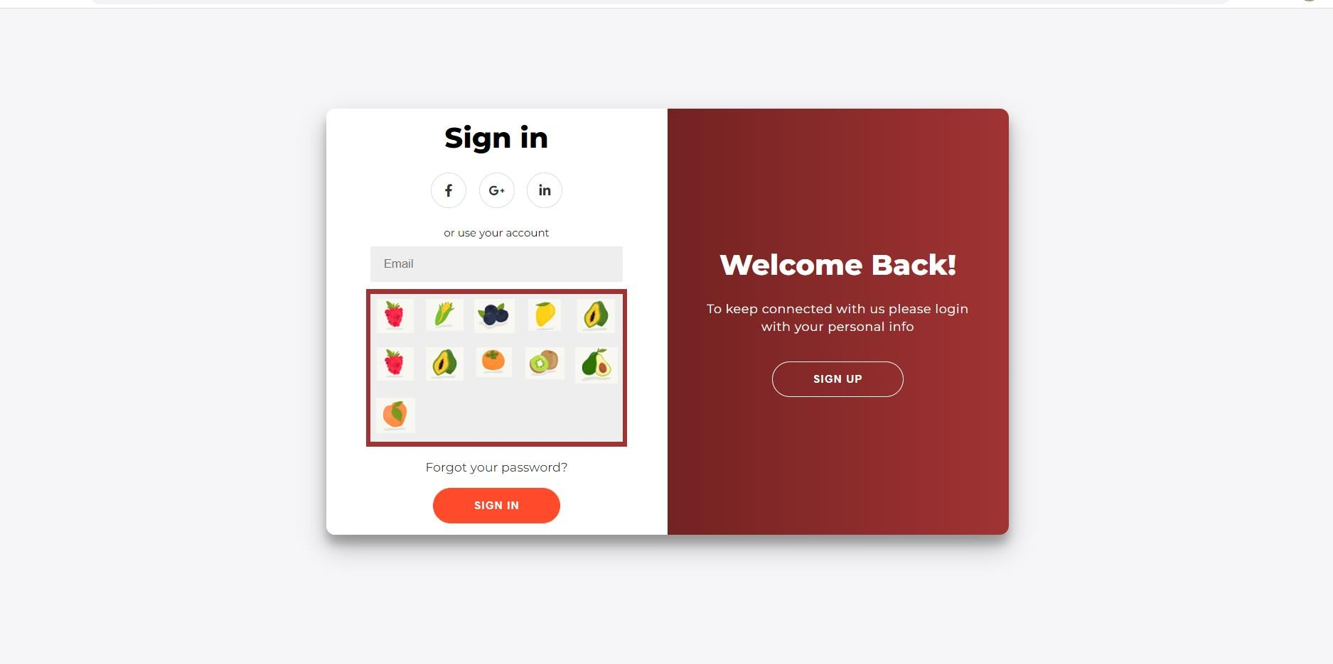

# CHAPTER 4 – RESULTS

The following are the results obtained after implementation – UI -

* + 1. **SignUp: for new user**
    2. **Login :**

### 2.1) Login : shuffling of images for same user:

* + 1. **Login Invalid :**

### Email notification for user for invalid attempt :

* + 1. **SignUp failed :**

### Preferences for user while signup :

* + 1. **Image splitting of a complete image :**

### image select dialog box :

**CHAPTER 5**

### DISCUSSION AND FUTURE WORK –

* Heavy DATABASE
* To Collect authentic information about colleges and their accreditions.
* To make the website Available for wide Range of

Colleges.

* To Enable the users interact with the Alumni of the

Respective Colleges.

# CHAPTER 6 REFERENCES –

* <https://youtu.be/RamIl-pjGE4>
* <https://youtu.be/QwrCPOO4LDc>
* https://youtu.be/eJcOHPkPiZg
* <https://www.javatpoint.com/how-to-sort-table-data-in-html-using-javascript>